3. Convert an Image to Outline Using the Canny Function in Python
Aim: To read an image in Python and convert it into an outline image using the Canny edge detection function.
Procedure
- Import the OpenCV library.
- Read the input image.
- Convert the image into grayscale.
- Apply the Canny function to detect edges.
- Display the original image and the outline image.
Code
import cv2

img = cv2.imread("sample.jpg")

gray = cv2.cvtColor(img, cv2.COLOR_BGR2GRAY)

edges = cv2.Canny(gray, 100, 200)

cv2.imshow("Original Image", img)
cv2.imshow("Outline Image", edges)

cv2.waitKey(0)
cv2.destroyAllWindows()
Input
An image named sample.jpg saved in the same folder as the Python program.
Output
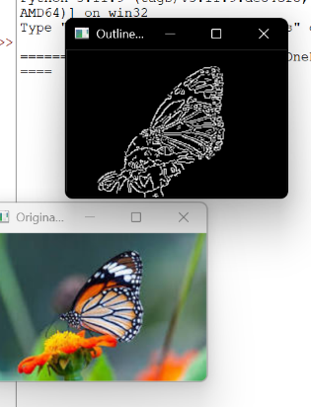
Result
The input image was successfully read using Python and converted into an outline image using the OpenCV Canny edge detection function.

